Community Futures Performance Results | 2021-22
Strong rural community strategic planning and implementation
1. Total number of community-based projects (new & on-going) | 15
2. Total number of local and regionally-based community strategic plans developed and/or updated | 1
Rural access to business development services
3. Total number of business training session participants | 126
4. Total number of business advisory services | 2382
Rural access to capital and leveraged capital
5. Dollar value of loans | $252,623.54
6. Total number of loans | 7
7. Number of jobs created/maintained/expanded through lending | 77
Provide additional Information (e.g. Success stories, Links to priorities, leveraging work, communication events, etc…)
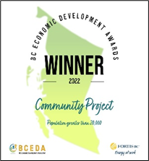
- SCF contributed significantly to the collaboration with the other CERN partners, including Community Futures South Fraser in various initiatives that supported Indigenous and non-Indigenous entrepreneurs. CERN was honoured to be recognized for the Workforce Summit virtual event held in February 2022 with the award for the 2022 BC Economic Development Award for Community Project (Population greater than 20,000).
Workforce Connection - https://chilliwackeconomicresourcenetwork.com/2022-workforce-summit-the-power-of-people/
Workforce Connection Digital Library - https://chilliwackeconomicresourcenetwork.com/
- Further expanded the SCF website as a key communication and resource tool for Indigenous entrepreneurs, including expanding the Stó:lō Business Directory by creating the Shop Stó:lō-Holiday Shopping Guide and the Indigenous Women’s Business sector on the Directory.
Stó:lō Business Directory - https://www.stolocf.ca/business-directory.html
- Indigenous Women-Owned or in Partnership Businesses - https://www.stolocf.ca/international-womens-day.html
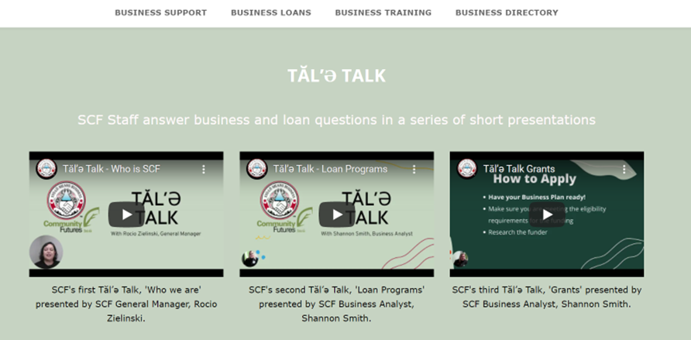
- Created the Tăl’ə Talk education series, which are short videos/presentations on topics promoting SCF services and answers commonly asked questions and inquiries. https://www.stolocf.ca/business-training.html

Estimated at the time of lending

