Stó:lō
COMMUNITY FUTURES
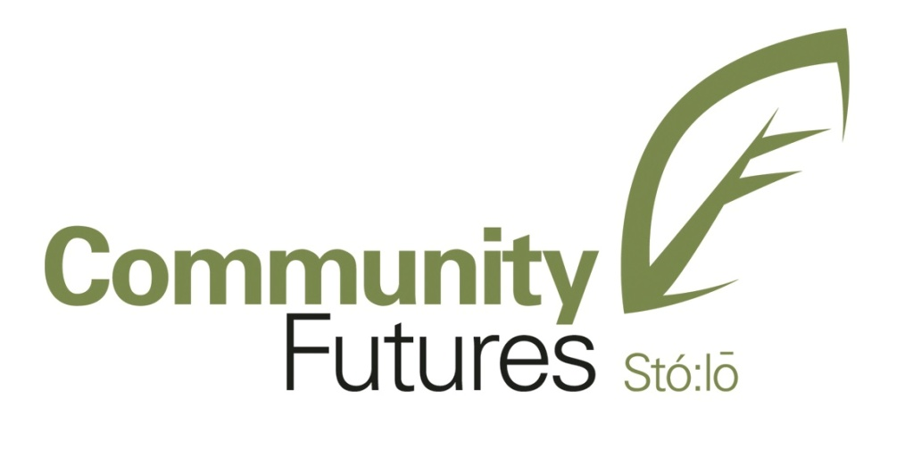

APPLICATION PROCESS
SCF Board of Directors Application
SCF Committee Member Application

STÓ:LŌ COMMUNITY FUTURES

VOLUNTEER APPLICATION

Name: ___________________________________________________________
Address:
Phone: Email:

The main skills that I bring to Stó:lō Community Futures are:

- ___________________________________________________________________
- ___________________________________________________________________
- ___________________________________________________________________
- ___________________________________________________________________
- ___________________________________________________________________

Highlights of my work / life experience of relevance to volunteering as a Board Member or Committee Member of Stó:lō Community Futures:

- ___________________________________________________________________
- ___________________________________________________________________
- ___________________________________________________________________
- ___________________________________________________________________
- ___________________________________________________________________

Highlights of my previous volunteer experience:

- __________________________________________________________________
- __________________________________________________________________
- __________________________________________________________________

Highlights of my involvement in Stó:lō and Indigenous Initiatives that would be beneficial to Stó:lō Community Futures:

- __________________________________________________________________
- __________________________________________________________________
- __________________________________________________________________

Why I want to serve as a Board or Committee Member of Stó:lō Community Futures:

What I feel Stó:lō Community Futures has to offer volunteers:

AREA(S) THAT MOST INTERST ME AT STÓ:LŌ COMMUNITY FUTURES:

Services to Indigenous businesses and entrepreneurs

Education and training programs for entrepreneurs

Economic strategies and community development

Building strategic partnerships

Raising funds for programs

I am interested in the SCF Board

I am interested in sitting on an SCF Committee:

Loan Funds Committee

Audit and Finance Committee

Time I have available (hours per month):

Other things Stó:lō Community Futures might like to know about me:

STÓ:LŌ COMMUNITY FUTURES

BOARD OF DIRECTORS

TERMS OF REFERENCE

Stó:lō Community Futures (SCF) Board Members are leaders within the Stó:lō Communities located in S’ólh Téméxw, the Stó:lō Traditional Territory. Leadership leads. Stó:lō Community Futures’ Board Members set policy. They may have the guidance and assistance of Committees and professional Staff; but the Board is ultimately responsible, both legally and organizationally. The Board Members are trustees who act on behalf of the organization’s Indigenous clients, Stó:lō First Nation communities, funders, strategic partners, various Government organizations and individual Indigenous and non-Indigenous stakeholders. The Board of Directors has the principal responsibility to fulfil the SCF’s Mission, Vision and are legally accountability for its operations.
MISSION:
Stó:lō Community Futures’ ongoing Mission is to provide Indigenous entrepreneurs and Stó:lō First Nation communities within S’ólh Téméxw, the Stó:lō Traditional Territory, with a wide range of business and economic development programs and services.

VISION:
The Vision of Stó:lō Community Futures is to facilitate and provide ongoing support to Indigenous businesses and to foster entrepreneurial growth in S’ólh Téméxw, Stó:lō Traditional Territory.

Specific responsibilities of Stó:lō Community Futures’ Board of Directors are as follows:
- To understand, respect and honour the philosophy underlying the Mission and Vision of SCF.
- To provide overall direction for the Organization and to be legally responsible for its management.
- To be accountable for the assets of the Organization and the actions undertaken by it.
- To be prepared to review and revise the Mission and Vision in accordance with evolving Stó:lō Community and Indigenous client needs.
- To show leadership for formulating goals, objectives, policies and guidelines.
- To set policies and strategic priorities and to delegate responsibility for the development of corresponding strategies to all SCF Committees.
- To establish Terms of Reference for all Committees.
- To ratify the appointment of Members in the Organization.
- To ensure effective communications among the Board of Directors.
- To present Stó:lō Community values to the Board and to present the Board’s point of view to the Stó:lō Communities, Community Members and its Indigenous and non-Indigenous stakeholders.
- To ensure that processes are in place to provide an environment for meaningful volunteer experiences.
- To ensure that the financial resources or other means needed to implement the Organizations plans are in place.
- Through the Chairman of the Board, to provide overall direction to the General Manager.
- To provide the means and conditions for the employment of Staff.
- To conduct an annual Board Orientation for all new Directors and to assist the Board in replacing Board Members as required.
- To carry out an annual review of the entire Board’s performance.
- To hold an Annual General Meeting for all Stó:lō Communities and Community Members.

Stó:lō Community Futures

BOARD OF DIRECTORS

POSITION DESCRIPTION

The Board of Directors of Stó:lō Community Futures Corporation, as a whole, provides the processes and tools to provide a meaningful volunteer experience for individual Directors, while assisting the economic growth and advancement of Stó:lō communities and stakeholders. In order for the Board to meet this commitment, individual Board Members will abide by the following:
VISION OF Stó:lō Community Futures:
The Vision of Stó:lō Community Futures is to facilitate and provide ongoing support to Indigenous businesses and to foster entrepreneurial growth in S’ólh Téméxw, Stó:lō Traditional Territory.

Performance Responsibilities:
- New Board Members attend an initial orientation session.
- Understand, sign-off on and abide by the existing Board policies of the Stó:lō Community Futures organization, specifically, the Board Member Code of Conduct, the Conflict of Interest Policies and Confidentiality Policies.
- Participate fully in formal volunteer development processes.
- Advocate for the Stó:lō Community Futures organization in the Stó:lō Communities, on a formal and an informal basis. Directors should represent Stó:lō Community Futures’ interests informally at other community meetings/events and may be required to formally present Stó:lō Community Futures’ interests at other business and community meetings.
- Be knowledgeable and responsible regarding overall finances of the organization.
- Express the Stó:lō Community point of view at the Board table.

Qualifications:
- Commitment to and demonstrated understanding of the Vision and Mission of the organization.
- Tact and ability to work with others.
- Time and willingness to serve.
- Knowledge of Stó:lō areas of service and population groups served within the Stó:lō Territories.

Time Commitment:
- Board Membership is a three-year term, up to a maximum nine year consecutive term. A one-year cool off period is required before returning to the Board for another nine-year term.
- Four to eight Board Meetings per year. Meetings are approximately one to two hours in length, plus preparation for each Meeting.

